Northern Arizona University
Wind Turbine Operation and Assembly Manual
April 5, 2019


Collegiate Wind Competition 2019
Mechanical Design Tunnel Team:
Riley Sinek (Blade & Pitching Design)
Tanner Lehr (Brake, Nacelle, & Tower Design)
Naser Alrashidi (Shaft Design)
Faisal Alrashidi (Yaw-Tail Design)

Faculty Mentors:
David Willy (Principle Advisor and Mechanical Technical Advisor)

Table of Contents
Assembly Manual 3
Step 1: Assemble Nacelle and Yaw 3
Step 2: Nacelle Components 4
Brakes 4
Shaft 4
Generator 5
Pitching 5
Hub & Blades 5
Assembly of Nacelle Components 6
Step 3: Tower and Yaw Bearing Assembly 7
Step 4: Tighten All Bolts 9
Step 5: Hook Up Electronics 9

Assembly Manual

In order to assemble the wind turbine the steps laid out in this document need to be taken. If anything is placed a little off center or not screwed in completely it could diminish the quality of the turbine and lead to catastrophic failure.

Step 1: Assemble Nacelle and Yaw

To start the assembly the first thing that is needed to be done is take the top, middle, and bottom plates for the nacelle and slide them into the connectors on the yaw. With that you can then put the cylindrical spacers in place and slide the bolts through.

Even though this finishes off attaching all of the nacelle do not tighten the bolts completely as you will need to take the bottom nacelle off in a future step. Even though it may seem like you are back tracking later on but it is easier to put everything together in this order.

Figure 1: Nacelle and Yaw

Step 2: Nacelle Components

All the individual components that are placed onto the nacelle can be done next. Having the nacelle put together allows for everything to be snapped into place and bolted down easier. All of the parts listed below should be assembled individually and then be placed onto the nacelle.

Brakes
The first thing needed to assemble the brakes is the front brake caliper and then the bearing block holder. These two parts can then be put together with the two bolt holes that are concentric with each other. The brake pads and brake rotor can then be placed in between the caliper and bearing block.

The big linear actuator can be placed onto the top plate of the nacelle because you do not need to wait for all the other parts.
Figure 2: Brake Caliper, Bearing Block, and Linear Actuator

Shaft
The shaft can then be slotted through the brake rotor and the bearing block. The shaft should be able to with ease but it will not be locked in yet.

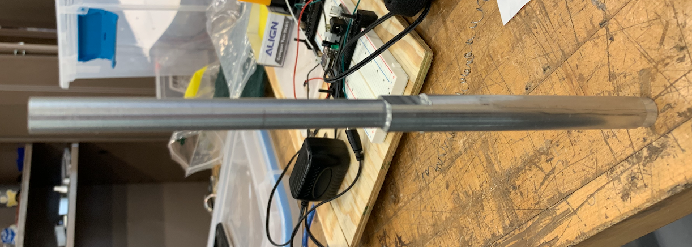
Figure 3: Shaft

Generator
The generator can then be placed onto the mounting plate with the 4 bolt holes on the backside. After this the shaft can then be attached to the front side of the generator with the 4 bolt holes.
Figure 4: Generator

Pitching
The swashplate can then be attached the front of the shaft and the linear actuators can be placed onto the top bolt holes in the brake caliper and bearing block. Then the linkage system between the actuators can be put together.

Hub & Blades
The 3 claws can be attached to the triangle hub. Once those are attached the blades can then be slotted into the claws. After placing the blades on the hub can then be screwed into the front of the shaft. Then the linkages from the pitching mechanism will be attached.
Figure 5: Pitching, Hub, and Claws

Figure 6: Blade

Assembly of Nacelle Components
With everything attached to each other it can easily be attached to the nacelle. There are slots that are built into the nacelle that the brakes, actuator, and generator to be moved forward and backwards to account for any play between all the systems.

Figure 7: All Nacelle Components

Step 3: Tower and Yaw Bearing Assembly
With everything connected to the nacelle the only thing left is to attach the tower and yaw bearing assembly. First, you will need to lay the nacelle on its side and take off the bottom nacelle plate. Do not take the bolts out completely as you will be putting it back on in a few moments.

Now you need to take the bottom nacelle plate and place the sleeve over the bearings that are on the tower. With the plate in place you can then put the retaining ring on. This makes it so everything is held together and nothing up-tower will be able to fall off. After placing the retaining ring in place take the slip ring and the slip ring spacer and place it on top of the tower. This allows all of the wires to twist with no problems as the turbine is yawing with the wind. Now with the nacelle still on its side you can then slot the bottom nacelle and tower back through the bolts that are on the rest of the nacelle.

Figure 8: Tower and Yaw Bearings | Figure 9: Yaw Bearing and Bottom Nacelle Connected

Figure 10: Slip Ring Attached

Step 4: Tighten All Bolts
During testing all of the bolts that are “hand tightened” will not stay in place while testing in a wind tunnel. This is due to the amount of vibration is caused by the wind and blades spinning fast. Nylock nuts should be used for all bolts and blue Loctite should be placed on the threads of each bolt as well. This allows the turbine to be tested as much as possible and not having to worry about any bolts unscrewing themselves.

Step 5: Hook Up Electronics
After the turbine is fully assembled as seen in the photo below, all electronics that are stored on the turbine and outside the wind tunnel can be hooked up. All electronics on the turbine will be attached on the middle nacelle. The electronics on the outside of the tunnel will be connected through the slip ring that goes through the tower.
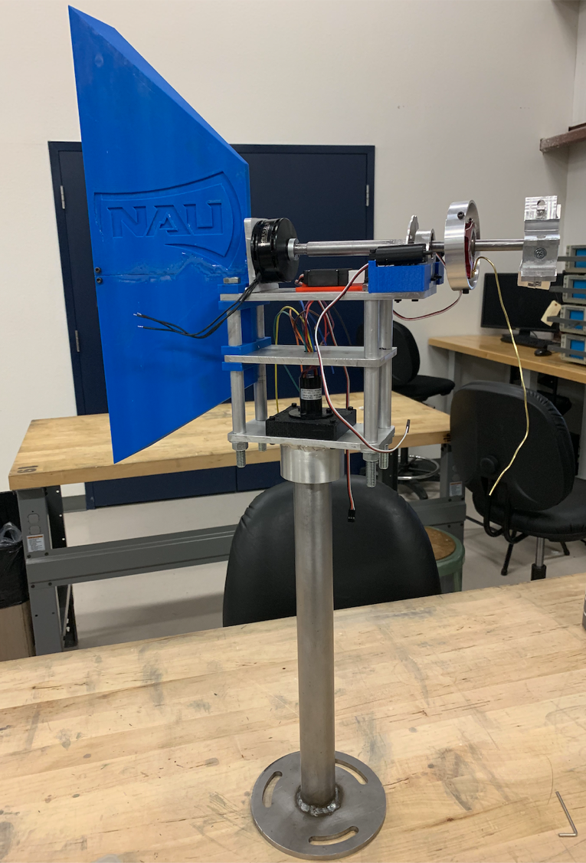
Figure 11: Fully Assembled Wind Turbine

